“MENTAL HEALTH GAME”

## A MINI-PROJECT REPORT

***Submitted by***

# KALPANA DEVI M (211421104117)

**NELLORE KAVYA SRI (211421104175)**

***In partial fulfilment of the award of the degree***

***of***

## BACHELOR OF ENGINEERING

**In**

**COMPUTER SCIENCE AND ENGINEERING**



# PANIMALAR ENGINEERING COLLEGE

**(An Autonomous Institution, Affiliated to Anna University, Chennai)**

OCTOBER 2023

# BONAFIDE CERTIFICATE

Certified that this project report **“MENTAL HEALTH GAME”** is bonafide work of **KALPANA DEVI M (211421104117) & NELLORE KAVYA SRI**

**(211421104175)** who carried out the project work under my supervision.

## SIGNATURE SIGNATURE Dr.L.JABASHEELA,M.E.,Ph.D., Mrs.D.JENNIFER,M.E.,(Ph.D)., HEAD OF THE DEPARTMENT SUPERVISOR

DEPARTMENT OF CSE, DEPARTMENT OF CSE,

PANIMALAR ENGINEERING COLLEGE, PANIMALAR ENGINEERING COLLEGE, NASARATHPETTAI, NASARATHPETTAI,

POONAMALLEE, POONAMALLEE,

CHENNAI-600 123. CHENNAI-600 123.

Certified that the above candidate(s) was/ were examined in the Anna University Project Viva-Voce Examination held on............................

**INTERNAL EXAMINER EXTERNAL EXAMINER**

# DECLARATION BY THE STUDENT

## We KALPANA DEVI (211421104117) & NELLORE KAVYA SRI

**(211421104175)** hereby declares that the project report titled **“MENTAL HEALTH GAME”**, Under the guidance of **D.JENNIFER, M.E,(Ph.D.)** is the original work done by us and we have not plagiarised or submitted to any other degree in any university by us.

**ACKNOWLEDGEMENT**

We would like to express our deep gratitude to our respected Secretary and Correspondent **Dr.P.CHINNADURAI, M.A., Ph.D.** for his kind words and enthusiastic motivation, which inspired us a lot in completing this project.

We express our sincere thanks to our Directors **Tmt.C.VIJAYARAJESWARI**, **Dr.C.SAKTHI KUMAR, M.E., Ph.D.** and **Dr.SARANYASREE SAKTHI**

**KUMAR B.E., M.B.A., Ph.D.** for providing us with the necessary facilities to undertake this project.

We also express our gratitude to our Principal **Dr.K.Mani, M.E., Ph.D.** who facilitated us in completing the project.

We thank the Head of the CSE Department, **Dr. L. JABASHEELA, M.E., Ph.D.** for the support extended throughout the project.

We would like to thank my Project Guide **Mrs.D.JENNIFER,M.E.,(Ph.D.)** ASSISTANT PROFESSOR and all the faculty members of the Department of CSE for their advice and encouragement for the successful completion of the project.

**KALPANA DEVI M (211421104117) NELLORE KAVYA SRI (211421104175)**

# ABSTRACT

The "Mental Health Games" website offers a diverse array of interactive games designed to promote and enhance mental well-being. Through a captivating and engaging platform, users can explore a range of games that serve as both entertaining pastimes and valuable tools for mental health improvement. Games such as chess, spelling bee, Connect Four, car racing, Harry Porter-themed adventures, snake and ladder, tic-tac-toe, and many more cater to a wide audience, providing options for different preferences and skill levels. The website integrates these classic and modern games with a mental health-oriented twist to encourage self-awareness, stress reduction, and cognitive improvement. In addition to fostering cognitive abilities and strategic thinking, "Mental Health Games " incorporates therapeutic elements to educate users about mental health, raise awareness, and facilitate emotional growth. Users can engage in relaxation activities, mindfulness exercises, and mood-boosting experiences through music and other soothing elements. The platform also introduces an interactive take on the popular game "Mad Libs," which encourages creative expression and fosters emotional release. Dots and boxes, a game of strategy and connection, further challenges users while promoting cognitive skills. By offering this diverse selection of games and activities, "Mental Health Games " aims to provide an accessible and enjoyable means for individuals to manage stress, improve mental health, and connect with others. It encourages social engagement, goal setting, and self-improvement, all while emphasizing the importance of mental well- being. Our app named “HAPPILO” is the platform where all the interactive modules are present to heal the users.

**TABLE OF CONTENTS**

|  |  |  |
| --- | --- | --- |
| **CHAPTER NO.** | **TITLE** | **PAGE NO.** |
|  | **LIST OF FIGURES** | 15 |
|  | Fig-(i) | 15 |
|  | Fig-(ii) | 16 |
| **1.** | **INTRODUCTION** | 1 |
|  | 1.1 Overview | 1 |
|  | 1.2 Problem Definition | 2 |
| **2.** | **LITERATURE SURVEY** | 4 |
| **3.** | **SYSTEM ANALYSIS** | 6 |
|  | 3.1 Proposed system | 7 |
|  | 3.2 System Requirement Specification | 8 |
|  | 3.3 Software Requirements | 9 |
| **4.** | **SYSTEM DESIGN** | 11 |
|  | 4.1 Data Flow Diagram | 11 |
|  | 4.2 UML Use-Case Diagram | 12 |
| **5.** | **SYSTEM ARCHITECTURE** | 13 |
|  | 5.1 Module Design Specification | 13 |
| **6.** | **SYSTEM IMPLEMENTATION** | 17 |
|  | 6.1 Coding | 17 |
| **7.** | **CONCLUSION** | 42 |
|  | 7.1 Conclusion and Future Enhancements | 42 |

|  |  |  |
| --- | --- | --- |
| **8.** | **APPENDICES** | 44 |
|  | A.1 Sample Screenshot | 44 |
| **9.** | **REFERENCES** | 51 |

**CHAPTER 1 INTRODUCTION**

In an increasingly fast-paced and interconnected world, maintaining our mental

well-being is a priority that can sometimes be overlooked. The demands of daily life, work, and personal challenges can take a toll on our mental health. Fortunately, technology offers innovative solutions to address these concerns, and one such solution is the "Mental Health Games" website. ”HAPPILO” is a unique online platform that recognizes the vital role games and interactive activities can play in nurturing mental health.

# OVERVIEW

"Mental Health Games" is not your average gaming website. It's a comprehensive and diverse platform designed to entertain, educate, and most importantly, contribute to the improvement of your mental well-being. The website offers a collection of classic and modern games, each thoughtfully integrated to provide users with a holistic experience. At "Mental Health Games"we believe in the power of play as a means to enhance mental well-being. Whether you're seeking relaxation, self-awareness, or cognitive improvement, our website offers a wide range of activities to cater to your needs. By blending the enjoyment of gaming with therapeutic elements and mental health education, " Mental Health Games " aims to make a positive impact on your mental health journey. Explore, have fun, and take steps towards a healthier, happier mind.

# PROBLEM DESCRIPTION

In our fast-paced, modern world, mental health has become a growing concern for many individuals. The daily stresses, pressures, and challenges we face can take a toll on our psychological and emotional well-being. Factors such as work-related stress, social isolation, academic pressure, financial worries, and personal issues can all contribute to mental health challenges like stress, anxiety, depression, and more. Moreover, there's still a significant stigma associated with seeking help for mental health issues, leading many to suffer in silence. The "Mental Health Games" website aims to address the following issues:

Mental Health Awareness: Many individuals lack a basic understanding of mental health, its importance, and the ways it can be managed and improved. " Mental Health Games " seeks to bridge this knowledge gap by incorporating educational elements into its games and activities, helping users become more aware of the importance of mental well-being.Stress Management: Stress is a ubiquitous problem in our lives, and it can have severe consequences for mental health. " Mental Health Games " offers stress reduction activities, relaxation techniques, and mindfulness exercises to help users better manage and alleviate stress.Social Isolation: Loneliness and social isolation can exacerbate mental health issues. By incorporating multiplayer and social gaming elements, " Mental Health Games " encourages users to connect with others, fostering a sense of community and support.Cognitive Improvement: Cognitive skills like memory, attention, and problem-solving are crucial for mental well-being. " Mental Health Games " provides games that not only entertain but also challenge these cognitive faculties, enhancing mental agility.

Stigma Reduction: The platform aims to reduce the stigma associated with seeking help for mental health issues by presenting mental health in a fun and engaging way, making it more approachable and relatable.It provides accessibility Traditional mental health support can be costly and difficult to access. " Mental Health Games " offers an accessible and cost-effective alternative, available to anyone with an internet connection.

Overall, " Mental Health Games " recognizes that mental health is a multifaceted issue and offers an innovative approach to address it. By combining the power of games, education, and community, this platform aims to be a valuable resource for those looking to enhance their mental well-being, reduce stress, and foster a deeper understanding of the importance of mental health.

# CHAPTER 2 LITERATURE SURVEY

A literature survey for a project focused on a mental health game website like "Mental Health Games" would involve researching and summarizing relevant studies, articles, and existing platforms that address similar themes and goals. Certainly, here's a literature survey with titles and descriptions of key studies and articles related to mental health games:

**TITLE:** Yi C, Tian Y, Arditi A. "The Efficacy of Game-Based Interventions in Mental Health Care"[1]

This review explores the effectiveness of game-based interventions for various mental health issues, including anxiety, depression, and stress. It assesses the impact of these games on user outcomes and engagement.

**DESCRIPTION:**

**TITLE:** Doush I.A., Al-BtoushS "Playful Minds: A Review of Educational and Therapeutic Games for Mental Health"[2]

**DESCRIPTION:** This literature review provides an overview of educational and therapeutic games used in mental health settings. It examines their effectiveness in teaching coping strategies, improving mood, and enhancing cognitive skills

**TITLE:** Pham T.D., Park Y.H., Kwon S.Y., Park K.R., Jeong D.S., S."Mindfulness and Stress Reduction in Digital Mental Health Platforms"[3]

**DESCRIPTION:** This research paper discusses the integration of mindfulness and stress reduction techniques in digital mental health platforms, including games. It assesses the impact of these tools on stress and anxiety reduction.

**TITLE:** A. Krishnamoorthy& V. Vijayarajan (2017) "Digital Accessibility in Mental Health Care: A Review of Online Platforms and Apps"[4]

**DESCRIPTION:** This review explores the role of online platforms and apps in making mental health resources more accessible. It evaluates the effectiveness of digital platforms in reaching a diverse audience and providing cost-effective support.

These studies and articles collectively shed light on the effectiveness of mental health games and their potential impact on various aspects of mental well-being. They cover topics ranging from gamification and cognitive training to the portrayal of mental health in video games and the role of online platforms in reducing stigma and providing accessible mental health support.

# CHAPTER 3 SYSTEM ANALYSIS

## Front-End Interface:

The user interface (UI) of the website should be intuitive, user-friendly, and responsive to provide an engaging experience. It should include user account management, game selection, and access to educational and support resources.

## Key Features:

1. User Accounts and Profiles:

Users can create accounts, customize profiles, and track their progress and achievements across games. User profiles may display game scores, educational achievements, and community participation.

1. Game Selection:

The platform offers a variety of mental health games, including chess, spelling bee, connect four, car racing, Harry Potter adventures, snake and ladder, tic-tac-toe, and others. Users can easily select and launch their chosen games.

1. Progress Tracking:

The system tracks user performance and progress within each game and provides feedback to help users improve. Users can set goals, track their achievements, and receive rewards for milestones.

1. Educational Resources:

Educational content is presented in a user-friendly format, offering articles, videos, and interactive quizzes on mental health topics. Users can access these

resources to learn more about stress management, coping strategies, and other relevant subjects.

1. Community and Social Interaction:

Users can connect with others through social features, including chat, forums, and multiplayer gaming options.Social interactions promote a sense of community and support.

1. Growing user base, with scalability features to accommodate more users and games as the platform expands.
2. High performance and fast response times are crucial to provide a smooth and enjoyable user experience.

## Proposed System

The "Mental Health Games" website is a comprehensive online platform designed to promote mental well-being, stress management, and cognitive development through an engaging collection of mental health games, educational resources, and a supportive community.

## Key Components:

1. User Profiles:

Users can create personalized accounts with unique profiles to track their progress and achievements across games. User profiles display game scores, educational milestones, and community engagement.

1. Game Selection:

The platform offers a variety of mental health games, including chess, spelling bee, connect four, car racing, Harry Potter adventures, snake and

ladder, tic-tac-toe, and more.Users can easily select and play their preferred games**.**

The proposed system for "Mental HealthGames" aims to provide a user- friendly, engaging, and educational platform for enhancing mental well-being and reducing stress.

## System Requirement Specification

"MindGames" mental health game website is a platform designed to promote mental well-being, stress management, and cognitive development through a collection of mental health games, educational resources, and a supportive community. This document outlines the system requirements necessary to create and maintain this platform effectively.

## Functional Requirements:

1. User Regision and Authentication:

Users should be able to create accounts and log in securely. Password reset functionality should be provided. Users must be authenticated before accessing personal data or games.

1. User Profiles:

Users can create, update, and personalize their profiles. Profiles should display user achievements, game scores, and educational milestones.

1. Game Selection:

The platform offers a variety of mental health games. Users can select and launch their preferred games. Games must run smoothly within the platform.

1. Progress Tracking:

The system tracks user performance within games and educational activities.

Users can set goals, track achievements, and earn virtual rewards. Game progress must be saved and accessible from user profiles.

1. Educational Resources:

A content management system (CMS) should allow for easy addition and management of educational content. Users can access articles, videos, and interactive quizzes on mental health topics.Educational content should be categorized and searchable.

1. Community and Social Interaction:

Users can interact with the community through chat rooms, forums, and multiplayer gaming. Social features must include user-friendly moderation tools to ensure a positive and safe environment.

1. Gamification Elements:

Gamification techniques, such as achievement badges, leaderboards, and virtual rewards, should be implemented.Users can compete for high scores and achievements.

This system requirement specification serves as the foundation for the development and operation of the "Mental Health Games" platform.

## Software Requirements

The software environment for the "MindGames" mental health game website involves a combination of technologies and tools that are essential for the development, deployment, and maintenance of the platform. Here's an overview of the software environment:

## Front-End Development:

HTML, CSS, and JavaScript: These are the fundamental technologies for building the website's user interface (UI). HTML provides the structure, CSS handles styling, and JavaScript adds interactivity. Front-End Frameworks: Popular frameworks like React, Angular, or Vue.js can be used for creating interactive and responsive user interfaces.

This software environment provides the necessary tools and technologies to develop and maintain the "Mental Health Games" website efficiently. The specific choice of technologies may vary based on development preferences, platform requirements, and scalability needs.

**USE-CASE DIAGRAM** **:**

# CHAPTER 4 SYSTEM DESIGN

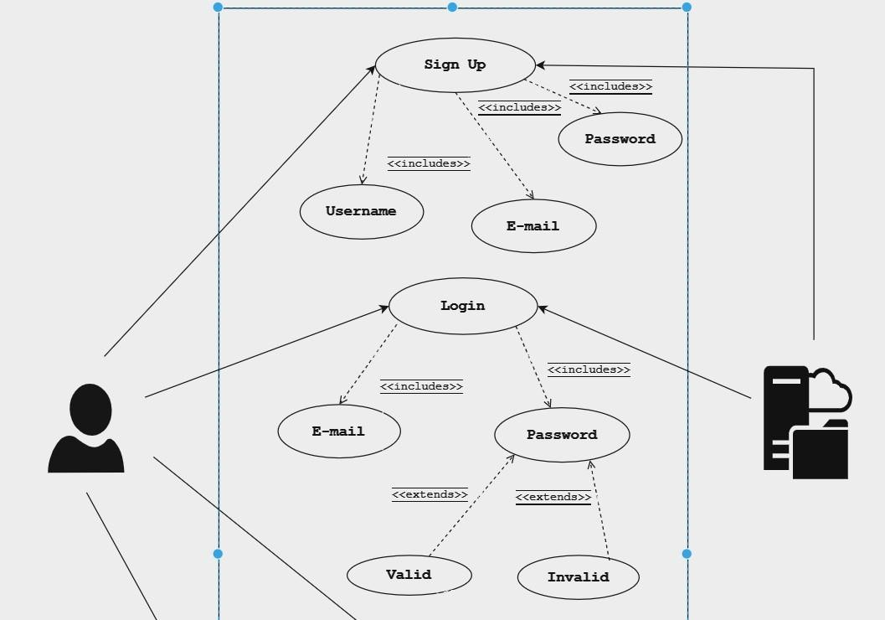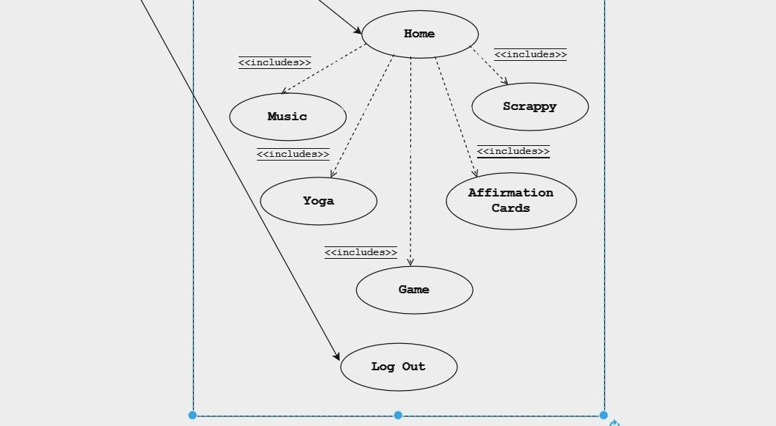

**DATA FLOW DIAGRAM :**

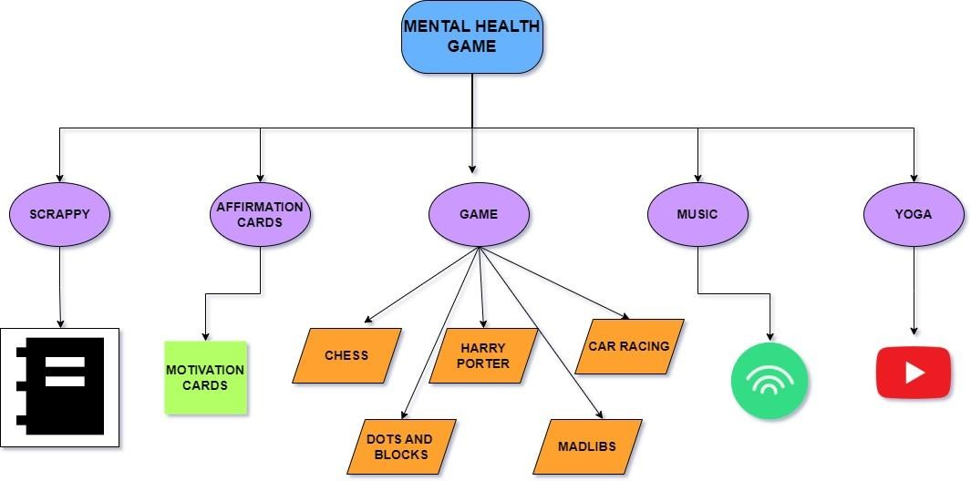

# CHAPTER 5 SYSTEM ARCHITECTURE

**5.1 MODULE DESIGN SPECIFICATION**

Happilo: Your Gateway to a Happier, Healthier You

Happilo - a multifaceted app designed to cater to various aspects of mental and emotional health. Comprising five modules, each with a distinct purpose, Happilo offers a holistic approach to self-improvement.

**Affirmation Cards: Self-Motivation at Your Fingertips**

The power of positive affirmations in transforming our mindset and bolstering our self-confidence cannot be underestimated. The Affirmation Cards module in Happilo serves as a daily dose of motivation, reminding users of their worth and potential. Through carefully crafted affirmations, individuals are encouraged to set positive intentions, cultivate a growth mindset, and navigate life's challenges with grace and determination.

## Music: Healing the Soul, Easing the Pain

Music has an unparalleled ability to touch the deepest recesses of our souls. The Music module in Happilo is not just about melodies; it's about curating a healing experience. Whether it's to soothe a troubled heart or elevate one's spirits, this module offers a diverse selection of music designed to evoke emotions, foster relaxation, and provide solace. With playlists tailored to different moods and situations, users can find their own musical sanctuary within Happilo.

## Game: Stress Relief Through Play

In the midst of life's demands, finding moments of respite is crucial. The Game module in Happilo offers a delightful way to unwind and de-stress. Engaging in interactive games not only provides an enjoyable escape but also stimulates cognitive functions, promoting mental agility and creativity. Whether it's a quick brain teaser or a leisurely game, this module encourages users to take a break, recharge, and return to their tasks with renewed focus.

## Yoga Videos: Nurturing Mind, Body, and Spirit

Yoga has been revered for centuries as a holistic practice that nurtures not only the physical body but also the mind and spirit. The Yoga Videos module in Happilo brings this ancient wisdom to modern fingertips. With a collection of guided yoga sessions, users can embark on a journey of self-discovery, stress reduction, and inner peace. From gentle stretches to challenging poses, this module caters to practitioners of all levels, helping them achieve a harmonious balance of body and mind.

## Scrappy: Entertainment for the Soul

Amidst the pursuit of personal growth and self-care, it's crucial to have moments of pure enjoyment and entertainment. Enter Scrappy, the module in Happilo dedicated to good old-fashioned fun. With an array of entertaining features, from games and puzzles to interactive experiences, Scrappy injects a dose of lightheartedness into the user's day. Laughter and amusement are not only cherished but actively encouraged in this corner of Happilo.

Happilo is more than just an app; it's a companion on the journey to self- improvement and well-being. With its five meticulously curated modules, Happilo offers a comprehensive toolkit for individuals seeking to enhance their mental and emotional health. Whether through affirmations, music, games, yoga, or simply enjoying moments of entertainment, users can find solace, motivation, and joy within this innovative application. Embrace Happilo and embark on a path to a happier, healthier you.

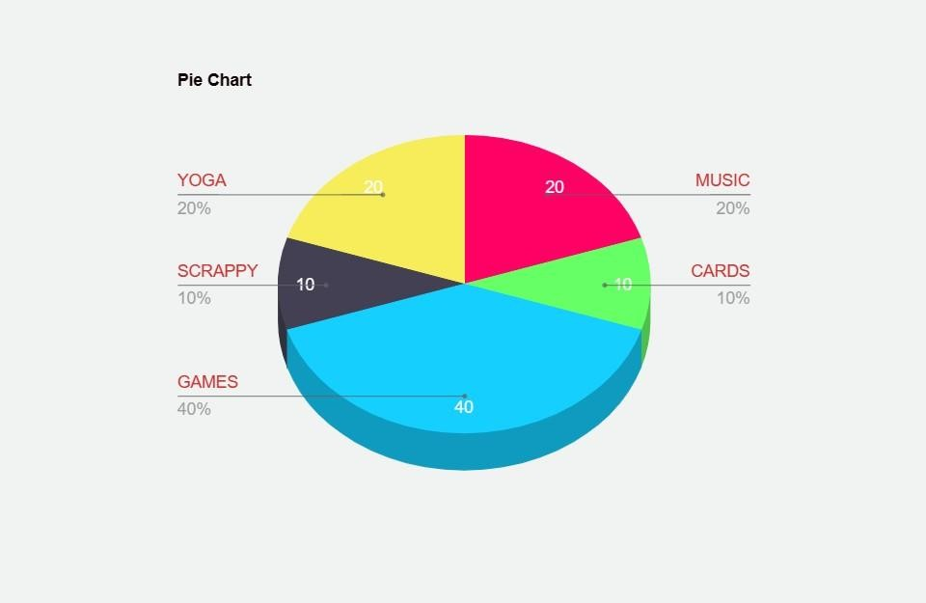

Fig-(i)

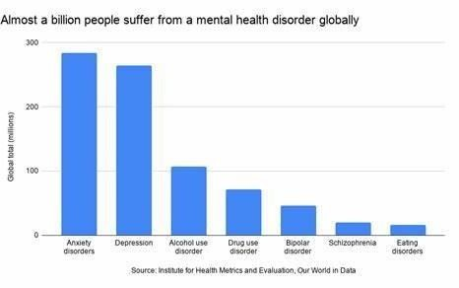

Fig-(ii)

# CODING :

Chess.html

<!DOCTYPE html>

<html lang="en">

<head>

# CHAPTER – 6 SYSTEM IMPLEMENTATION

<meta charset="UTF-8">

<meta http-equiv="X-UA-Compatible" content="IE=edge">

<meta name="viewport" content="width=device-width, initial-scale=1.0">

<meta name="author" content="Jahid Khan">

<title>Chess</title>

<style>

* {

margin: 0;

padding: 0;

}

body {

display: grid;

place-items: center; overflow-x: hidden;

}

h1 {

margin: 10px;

}

ul {

display: grid;

grid-template-columns: 1fr;

}

.divv {

display: flex;

}

li {

list-style: none; display: grid;

place-items: center; font-size: 0px;

}

.box {

margin: .5px; width: 75px; height: 75px;

}

#tog {

margin: 10px 0px;

}

.allimg { width: 45px;

position: relative; bottom: 5px;

}

.allpawn {

transform: scale(.7);

}

.authcont { width: 100vw;

}

.author { float: right;

margin-right: 50px;

}

@media (max-width:650px){ #tog {

margin-bottom: 70px;

}

.box {

width: 11vw; height: 11vw;

}

.allimg { width: 7vw;

}

}

</style>

</head>

<body>

<h1>Chess</h1>

<h2 id="tog">White's Turn</h2>

<ul>

<div class="divv" id="row8">

<li class="box" id="b801">Brook</li>

<li class="box" id="b802">Bknight</li>

<li class="box" id="b803">Bbishop</li>

<li class="box" id="b804">Bqueen</li>

<li class="box" id="b805">Bking</li>

<li class="box" id="b806">Bbishop</li>

<li class="box" id="b807">Bknight</li>

<li class="box" id="b808">Brook</li>

</div>

<div class="divv" id="row7">

<li class="box" id="b701">Bpawn</li>

<li class="box" id="b702">Bpawn</li>

<li class="box" id="b703">Bpawn</li>

<li class="box" id="b704">Bpawn</li>

<li class="box" id="b705">Bpawn</li>

<li class="box" id="b706">Bpawn</li>

<li class="box" id="b707">Bpawn</li>

<li class="box" id="b708">Bpawn</li>

</div>

<div class="divv" id="row6">

<li class="box" id="b601"></li>

<li class="box" id="b602"></li>

<li class="box" id="b603"></li>

<li class="box" id="b604"></li>

<li class="box" id="b605"></li>

<li class="box" id="b606"></li>

<li class="box" id="b607"></li>

<li class="box" id="b608"></li>

</div>

<div class="divv" id="row5">

<li class="box" id="b501"></li>

<li class="box" id="b502"></li>

<li class="box" id="b503"></li>

<li class="box" id="b504"></li>

<li class="box" id="b505"></li>

<li class="box" id="b506"></li>

<li class="box" id="b507"></li>

<li class="box" id="b508"></li>

</div>

<div class="divv" id="row4">

<li class="box" id="b401"></li>

<li class="box" id="b402"></li>

<li class="box" id="b403"></li>

<li class="box" id="b404"></li>

<li class="box" id="b405"></li>

<li class="box" id="b406"></li>

<li class="box" id="b407"></li>

<li class="box" id="b408"></li>

</div>

<div class="divv" id="row3">

<li class="box" id="b301"></li>

<li class="box" id="b302"></li>

<li class="box" id="b303"></li>

<li class="box" id="b304"></li>

<li class="box" id="b305"></li>

<li class="box" id="b306"></li>

<li class="box" id="b307"></li>

<li class="box" id="b308"></li>

</div>

<div class="divv" id="row2">

<li class="box Wpawn" id="b201">Wpawn</li>

<li class="box Wpawn" id="b202">Wpawn</li>

<li class="box Wpawn" id="b203">Wpawn</li>

<li class="box Wpawn" id="b204">Wpawn</li>

<li class="box Wpawn" id="b205">Wpawn</li>

<li class="box Wpawn" id="b206">Wpawn</li>

<li class="box Wpawn" id="b207">Wpawn</li>

<li class="box Wpawn" id="b208">Wpawn</li>

</div>

<div class="divv" id="row1">

<li class="box" id="b101">Wrook</li>

<li class="box" id="b102">Wknight</li>

<li class="box" id="b103">Wbishop</li>

<li class="box" id="b104">Wqueen</li>

<li class="box" id="b105">Wking</li>

<li class="box" id="b106">Wbishop</li>

<li class="box" id="b107">Wknight</li>

<li class="box" id="b108">Wrook</li>

</div>

</ul>

<script>

// Inserting the Images function insertImage() {

document.querySelectorAll('.box').forEach(image => { if (image.innerText.length !== 0) {

if (image.innerText == 'Wpawn' || image.innerText == 'Bpawn') {

image.innerHTML = `${image.innerText} <img class='allimg allpawn' src="${image.innerText}.png" alt="">`

image.style.cursor = 'pointer'

}

else {

image.innerHTML = `${image.innerText} <img class='allimg' src="${image.innerText}.png" alt="">`

image.style.cursor = 'pointer'

}

}

})

}

insertImage()

//Coloring

function coloring() {

const color = document.querySelectorAll('.box') color.forEach(color => {

getId = color.id

arr = Array.from(getId) arr.shift()

aside = eval(arr.pop()) aup = eval(arr.shift()) a = aside + aup

if (a % 2 == 0) {

color.style.backgroundColor = 'rgb(240, 201, 150)'

}

if (a % 2 !== 0) {

color.style.backgroundColor = 'rgb(100, 75, 43)'

}

// if (a % 2 == 0) {

// color.style.backgroundColor = 'seagreen'

// }

// if (a % 2 !== 0) {

// color.style.backgroundColor = 'lime'

// }

})

}

coloring()

//function to not remove the same team element function reddish() {

document.querySelectorAll('.box').forEach(i1 => { if (i1.style.backgroundColor == 'pink') {

document.querySelectorAll('.box').forEach(i2 => {

if (i2.style.backgroundColor == 'green' && i2.innerText.length !== 0) {

greenText = i2.innerText pinkText = i1.innerText

pinkColor = ((Array.from(pinkText)).shift()).toString() greenColor = ((Array.from(greenText)).shift()).toString() getId = i2.id

arr = Array.from(getId) arr.shift()

aside = eval(arr.pop()) aup = eval(arr.shift()) a = aside + aup

if (a % 2 == 0 && pinkColor == greenColor) { i2.style.backgroundColor = 'rgb(240, 201, 150)'

}

if (a % 2 !== 0 && pinkColor == greenColor) { i2.style.backgroundColor = 'rgb(100, 75, 43)'

}

// if (pinkColor == greenColor) {

// i2.style.backgroundColor = 'rgb(253, 60, 60)'

// }

}

})

}

})

}

tog = 1 whiteCastleChance=true blackCastleChance=true

document.querySelectorAll('.box').forEach(item => { item.addEventListener('click', function () {

// To delete the opposite element

if (item.style.backgroundColor == 'green' && item.innerText.length == 0) { tog = tog + 1

}

else if (item.style.backgroundColor == 'aqua' && item.innerText.length == 0) { tog = tog + 1

}

else if (item.style.backgroundColor == 'green' && item.innerText.length !== 0) { document.querySelectorAll('.box').forEach(i => {

if (i.style.backgroundColor == 'pink') { pinkId = i.id

pinkText = i.innerText document.getElementById(pinkId).innerText = '' item.innerText = pinkText

coloring() insertImage() tog = tog + 1

}

})

}

getId = item.id

arr = Array.from(getId) arr.shift()

aside = eval(arr.pop()) arr.push('0')

aup = eval(arr.join('')) a = aside + aup

// Function to display the available paths for all pieces function whosTurn(toggle) {

// PAWN

if (item.innerText == `${toggle}pawn`) {

item.style.backgroundColor = 'pink' if (tog % 2 !== 0 && aup < 800) {

if (aup == 200 && document.getElementById(`b${a + 100}`).innerText.length == 0) {

document.getElementById(`b${a + 100}`).style.backgroundColor =

'green'

if (aup == 200 && document.getElementById(`b${a +

200}`).innerText.length == 0) {

document.getElementById(`b${a + 200}`).style.backgroundColor =

'green'

}

}

if (aup !== 200 && document.getElementById(`b${a + 100}`).innerText.length == 0) {

document.getElementById(`b${a + 100}`).style.backgroundColor =

'green'

}

if (aside < 8 && document.getElementById(`b${a + 100 +

1}`).innerText.length !== 0) {

document.getElementById(`b${a + 100 + 1}`).style.backgroundColor =

'green'

}

if (aside > 1 && document.getElementById(`b${a + 100 -

1}`).innerText.length !== 0) {

document.getElementById(`b${a + 100 - 1}`).style.backgroundColor =

'green'

}

// if (aup == 800) {

// document.getElementById(`b${a}`).innerText = 'Wqueen'

// coloring()

// insertImage()

// }

// if (aside < 8 && document.getElementById(`b${a + 100 +

1}`).innerText.length == 0 && document.getElementById(`b${a + 100}`).innerText.length == 0) {

'green'

// document.getElementById(`b${a + 100}`).style.backgroundColor =

// }

// if (aside > 1 && document.getElementById(`b${a + 100 -

1}`).innerText.length == 0 && document.getElementById(`b${a + 100}`).innerText.length == 0) {

// document.getElementById(`b${a + 100}`).style.backgroundColor =

'green'

// }

}

if (tog % 2 == 0 && aup > 100) {

if (aup == 700 && document.getElementById(`b${a - 100}`).innerText.length == 0) {

document.getElementById(`b${a - 100}`).style.backgroundColor = 'green' if (aup == 700 && document.getElementById(`b${a -

200}`).innerText.length == 0) {

document.getElementById(`b${a - 200}`).style.backgroundColor =

'green'

}

}

if (aup !== 700 && document.getElementById(`b${a - 100}`).innerText.length == 0) {

document.getElementById(`b${a - 100}`).style.backgroundColor = 'green'

}

if (aside < 8 && document.getElementById(`b${a - 100 + 1}`).innerText.length !== 0) {

document.getElementById(`b${a - 100 + 1}`).style.backgroundColor =

'green'

}

if (aside > 1 && document.getElementById(`b${a - 100 -

1}`).innerText.length !== 0) {

document.getElementById(`b${a - 100 - 1}`).style.backgroundColor =

'green'

}

}

}

// KING

if (item.innerText == `${toggle}king`) { if (aside < 8) {

document.getElementById(`b${a + 1}`).style.backgroundColor = 'green'

}

if (aside > 1) {

document.getElementById(`b${a - 1}`).style.backgroundColor = 'green'

}

if (aup < 800) {

document.getElementById(`b${a + 100}`).style.backgroundColor = 'green'

}

if (aup > 100) {

document.getElementById(`b${a - 100}`).style.backgroundColor = 'green'

'green'

**}**

if (aup > 100 && aside < 8) {

document.getElementById(`b${a - 100 + 1}`).style.backgroundColor =

'green'

**}**

if (aup > 100 && aside > 1) {

document.getElementById(`b${a - 100 - 1}`).style.backgroundColor =

'green'

**}**

if (aup < 800 && aside < 8) {

document.getElementById(`b${a + 100 + 1}`).style.backgroundColor =

'green'

**}**

if (aup < 800 && aside > 1) {

document.getElementById(`b${a + 100 - 1}`).style.backgroundColor =

}

if(whiteCastleChance==true && a==105 && document.getElementById('b106').innerText== '' && document.getElementById('b107').innerText== '' && document.getElementById('b108').innerText== 'Wrook'){

document.getElementById(`b107`).style.backgroundColor = 'aqua'

}

if(whiteCastleChance==true && a==105 && document.getElementById('b104').innerText== '' && document.getElementById('b103').innerText== '' && document.getElementById('b102').innerText== '' && document.getElementById('b101').innerText== 'Wrook'){

document.getElementById(`b103`).style.backgroundColor = 'aqua'

}

if(blackCastleChance==true && a==805 && document.getElementById('b806').innerText== '' && document.getElementById('b807').innerText== '' && document.getElementById('b808').innerText== 'Brook'){

document.getElementById(`b807`).style.backgroundColor = 'aqua'

}

if(blackCastleChance==true && a==805 && document.getElementById('b804').innerText== '' && document.getElementById('b803').innerText== '' && document.getElementById('b802').innerText== '' && document.getElementById('b801').innerText== 'Brook'){

document.getElementById(`b803`).style.backgroundColor = 'aqua'

}

item.style.backgroundColor = 'pink'

}

// ROOK

if (item.innerText == `${toggle}rook`) { for (let i = 1; i < 9; i++) {

if ((a + i * 100) < 900 && document.getElementById(`b${a + i * 100}`).innerText == 0) {

document.getElementById(`b${a + i * 100}`).style.backgroundColor =

'green'

}

else if ((a + i * 100) < 900 && document.getElementById(`b${a + i * 100}`).innerText !== 0) {

document.getElementById(`b${a + i * 100}`).style.backgroundColor =

'green'

break

}

}

for (let i = 1; i < 9; i++) {

if ((a - i * 100) > 100 && document.getElementById(`b${a - i * 100}`).innerText == 0) {

document.getElementById(`b${a - i * 100}`).style.backgroundColor =

'green'

}

else if ((a - i * 100) > 100 && document.getElementById(`b${a - i *

100}`).innerText !== 0) {

document.getElementById(`b${a - i * 100}`).style.backgroundColor =

'green'

break

}

}

== 0) {

for (let i = 1; i < 9; i++) {

if ((a + i) < (aup + 9) && document.getElementById(`b${a + i}`).innerText

document.getElementById(`b${a + i}`).style.backgroundColor = 'green'

}

else if ((a + i) < (aup + 9) && document.getElementById(`b${a +

i}`).innerText !== 0) {

document.getElementById(`b${a + i}`).style.backgroundColor = 'green' break

}

}

for (let i = 1; i < 9; i++) {

if ((a - i) > (aup) && document.getElementById(`b${a - i}`).innerText == 0)

{

document.getElementById(`b${a - i}`).style.backgroundColor = 'green'

}

!== 0) {

else if ((a - i) > (aup) && document.getElementById(`b${a - i}`).innerText

document.getElementById(`b${a - i}`).style.backgroundColor = 'green' break

}

}

item.style.backgroundColor = 'pink'

}

// BISHOP

if (item.innerText == `${toggle}bishop`) { for (let i = 1; i < 9; i++) {

if (i < (900 - aup) / 100 && i < 9 - aside && document.getElementById(`b${a + i * 100 + i}`).innerText.length == 0) {

document.getElementById(`b${a + i * 100 + i}`).style.backgroundColor =

'green'

}

else if (i < (900 - aup) / 100 && i < 9 - aside &&

document.getElementById(`b${a + i * 100 + i}`).innerText.length !== 0) {

document.getElementById(`b${a + i * 100 + i}`).style.backgroundColor =

'green'

break

}

}

for (let i = 1; i < 9; i++) {

if (i < aup / 100 && i < 9 - aside && document.getElementById(`b${a - i * 100 + i}`).innerText.length == 0) {

document.getElementById(`b${a - i * 100 + i}`).style.backgroundColor =

'green'

}

else if (i < aup / 100 && i < 9 - aside && document.getElementById(`b${a - i

* 100 + i}`).innerText.length !== 0) {

'green'

document.getElementById(`b${a - i * 100 + i}`).style.backgroundColor =

break

}

}

for (let i = 1; i < 9; i++) {

if (i < (900 - aup) / 100 && i < aside && document.getElementById(`b${a + i * 100 - i}`).innerText.length == 0) {

document.getElementById(`b${a + i * 100 - i}`).style.backgroundColor =

'green'

}

else if (i < (900 - aup) / 100 && i < aside &&

document.getElementById(`b${a + i * 100 - i}`).innerText.length !== 0) {

document.getElementById(`b${a + i * 100 - i}`).style.backgroundColor =

'green'

break

}

}

for (let i = 1; i < 9; i++) {

if (i < aup / 100 && i < aside && document.getElementById(`b${a - i * 100 - i}`).innerText.length == 0) {

document.getElementById(`b${a - i * 100 - i}`).style.backgroundColor =

'green'

}

else if (i < aup / 100 && i < aside && document.getElementById(`b${a - i *

100 - i}`).innerText.length !== 0) {

document.getElementById(`b${a - i * 100 - i}`).style.backgroundColor =

'green'

break

}

}

item.style.backgroundColor = 'pink'

}

// QUEEN

if (item.innerText == `${toggle}queen`) { for (let i = 1; i < 9; i++) {

if ((a + i * 100) < 900 && document.getElementById(`b${a + i * 100}`).innerText == 0) {

document.getElementById(`b${a + i * 100}`).style.backgroundColor =

'green'

}

else if ((a + i * 100) < 900 && document.getElementById(`b${a + i *

100}`).innerText !== 0) {

document.getElementById(`b${a + i * 100}`).style.backgroundColor =

'green'

break

}

}

for (let i = 1; i < 9; i++) {

if ((a - i * 100) > 100 && document.getElementById(`b${a - i * 100}`).innerText == 0) {

document.getElementById(`b${a - i * 100}`).style.backgroundColor =

'green'

}

else if ((a - i * 100) > 100 && document.getElementById(`b${a - i *

100}`).innerText !== 0) {

document.getElementById(`b${a - i * 100}`).style.backgroundColor =

'green'

break

}

}

== 0) {

for (let i = 1; i < 9; i++) {

if ((a + i) < (aup + 9) && document.getElementById(`b${a + i}`).innerText

document.getElementById(`b${a + i}`).style.backgroundColor = 'green'

}

else if ((a + i) < (aup + 9) && document.getElementById(`b${a +

i}`).innerText !== 0) {

document.getElementById(`b${a + i}`).style.backgroundColor = 'green' break

}

}

{

!== 0) {

for (let i = 1; i < 9; i++) {

if ((a - i) > (aup) && document.getElementById(`b${a - i}`).innerText == 0)

document.getElementById(`b${a - i}`).style.backgroundColor = 'green'

}

else if ((a - i) > (aup) && document.getElementById(`b${a - i}`).innerText

document.getElementById(`b${a - i}`).style.backgroundColor = 'green' break

}

}

for (let i = 1; i < 9; i++) {

if (i < (900 - aup) / 100 && i < 9 - aside && document.getElementById(`b${a + i * 100 + i}`).innerText.length == 0) {

document.getElementById(`b${a + i * 100 + i}`).style.backgroundColor =

'green'

}

else if (i < (900 - aup) / 100 && i < 9 - aside &&

document.getElementById(`b${a + i * 100 + i}`).innerText.length !== 0) {

document.getElementById(`b${a + i * 100 + i}`).style.backgroundColor =

'green'

break

}

}

for (let i = 1; i < 9; i++) {

if (i < aup / 100 && i < 9 - aside && document.getElementById(`b${a - i * 100 + i}`).innerText.length == 0) {

document.getElementById(`b${a - i * 100 + i}`).style.backgroundColor =

'green'

}

else if (i < aup / 100 && i < 9 - aside && document.getElementById(`b${a - i

* 100 + i}`).innerText.length !== 0) {

document.getElementById(`b${a - i * 100 + i}`).style.backgroundColor =

'green'

break

}

}

for (let i = 1; i < 9; i++) {

if (i < (900 - aup) / 100 && i < aside && document.getElementById(`b${a + i * 100 - i}`).innerText.length == 0) {

document.getElementById(`b${a + i * 100 - i}`).style.backgroundColor =

'green'

}

else if (i < (900 - aup) / 100 && i < aside &&

document.getElementById(`b${a + i * 100 - i}`).innerText.length !== 0) {

document.getElementById(`b${a + i * 100 - i}`).style.backgroundColor =

'green'

break

}

}

for (let i = 1; i < 9; i++) {

if (i < aup / 100 && i < aside && document.getElementById(`b${a - i * 100 - i}`).innerText.length == 0) {

document.getElementById(`b${a - i * 100 - i}`).style.backgroundColor =

'green'

}

else if (i < aup / 100 && i < aside && document.getElementById(`b${a - i *

100 - i}`).innerText.length !== 0) {

document.getElementById(`b${a - i * 100 - i}`).style.backgroundColor =

'green'

break

}

}

item.style.backgroundColor = 'pink'

}

'green'

// KNIGHT

if (item.innerText == `${toggle}knight`) { if (aside < 7 && aup < 800) {

document.getElementById(`b${a + 100 + 2}`).style.backgroundColor =

'green'

**}**

if (aside < 7 && aup > 200) {

document.getElementById(`b${a - 100 + 2}`).style.backgroundColor =

'green'

**}**

if (aside < 8 && aup < 700) {

document.getElementById(`b${a + 200 + 1}`).style.backgroundColor =

'green'

**}**

if (aside > 1 && aup < 700) {

document.getElementById(`b${a + 200 - 1}`).style.backgroundColor =

'green'

**}**

if (aside > 2 && aup < 800) {

document.getElementById(`b${a - 2 + 100}`).style.backgroundColor =

'green'

**}**

if (aside > 2 && aup > 100) {

document.getElementById(`b${a - 2 - 100}`).style.backgroundColor =

'green'

**}**

if (aside < 8 && aup > 200) {

document.getElementById(`b${a - 200 + 1}`).style.backgroundColor =

}

if (aside > 1 && aup > 200) {

'green'

document.getElementById(`b${a - 200 - 1}`).style.backgroundColor =

}

item.style.backgroundColor = 'pink'

}

}

// Toggling the turn if (tog % 2 !== 0) {

document.getElementById('tog').innerText = "White's Turn" whosTurn('W')

}

if (tog % 2 == 0) {

document.getElementById('tog').innerText = "Black's Turn" whosTurn('B')

}

reddish()

// winning() numOfKings = 0

document.querySelectorAll('.box').forEach(win => {

if (win.innerText == 'Wking' || win.innerText == 'Bking') { numOfKings += 1

}

})

if (numOfKings == 1) { setTimeout(() => {

// console.log(`${toggle}`) if (tog % 2 == 0) {

alert('White Wins !!') location.reload()

}

else if (tog % 2 !== 0) {

alert('Black Wins !!') location.reload()

}

}, 100)

}

})

})

// Moving the element document.querySelectorAll('.box').forEach(item => {

item.addEventListener('click', function () {

if (item.style.backgroundColor == 'pink') { pinkId = item.id

pinkText = item.innerText document.querySelectorAll('.box').forEach(item2 => {

item2.addEventListener('click', function () { getId = item2.id

arr = Array.from(getId) arr.shift()

aside = eval(arr.pop()) arr.push('0')

aup = eval(arr.join('')) a = aside + aup

if (item2.style.backgroundColor == 'green' && item2.innerText.length == 0)

{

if (pinkText == `Wpawn` && aup == 800) { document.getElementById(`b${a}`).innerText = 'Wqueen' document.getElementById(pinkId).innerText = '' coloring()

insertImage()

}

else if (pinkText == `Bpawn` && aup == 100) {

document.getElementById(`b${a}`).innerText = 'Bqueen' document.getElementById(pinkId).innerText = '' coloring()

insertImage()

}

else {

document.getElementById(pinkId).innerText = '' item2.innerText = pinkText

coloring() insertImage()

}

}

else if (item2.style.backgroundColor == 'aqua') { if(item2.id=='b103'){

document.getElementById('b101').innerText = '' document.getElementById('b102').innerText = '' document.getElementById('b103').innerText = 'Wking' document.getElementById('b104').innerText = 'Wrook' document.getElementById('b105').innerText = '' document.getElementById(pinkId).innerText = '' whiteCastleChance=false

coloring() insertImage()

}

else if(item2.id=='b107'){ document.getElementById('b105').innerText = '' document.getElementById('b106').innerText = 'Wrook' document.getElementById('b107').innerText = 'Wking' document.getElementById('b108').innerText = '' document.getElementById(pinkId).innerText = ''

whiteCastleChance=false coloring()

insertImage()

}

else if(item2.id=='b803'){ document.getElementById('b801').innerText = '' document.getElementById('b802').innerText = '' document.getElementById('b803').innerText = 'Bking' document.getElementById('b804').innerText = 'Brook' document.getElementById('b805').innerText = '' document.getElementById(pinkId).innerText = '' blackCastleChance=false

coloring() insertImage()

}

else if(item2.id=='b807'){ document.getElementById('b805').innerText = '' document.getElementById('b806').innerText = 'Brook' document.getElementById('b807').innerText = 'Bking' document.getElementById('b808').innerText = '' document.getElementById(pinkId).innerText = '' blackCastleChance=false

coloring() insertImage()

}

}

})

})

}

})

})

// Prvents from selecting multiple elements z = 0

document.querySelectorAll('.box').forEach(ee => { ee.addEventListener('click', function () {

z = z + 1

if (z % 2 == 0 && ee.style.backgroundColor !== 'green' && ee.style.backgroundColor !== 'aqua') {

coloring()

}

})

})

</script>

</body>

</html>

# CHAPTER – 7 CONCLUSION

The "Mental Health Games" website is envisioned as a versatile platform that seeks to promote mental well-being, stress management, and cognitive development through a range of engaging games, educational resources, and a supportive community. This platform offers a holistic approach to mental health, combining gaming elements, education, and social interaction in a secure and user-friendly environment. By focusing on user engagement, gamification, and educational content, "Mental Health Games" aims to make a positive impact on users' mental health and well-being. The inclusion of features like progress tracking, multiplayer games, and a community forum fosters a sense of belonging and support.The website's software environment encompasses the latest technologies and tools necessary for development, deployment, and maintenance, ensuring a high-quality user experience. Strong security measures and compliance with data protection regulations are integral to protect user data and privacy.

**FUTURE ENHANCEMENTS**

To further improve and expand the "Mental Health Games" platform, several future enhancements can be considered:

1. Enhanced Game Library: Continuously update and expand the collection of mental health games to cater to a broader audience and diverse preferences. Explore collaborations with game developers for exclusive content.
2. Mobile Apps: Develop mobile applications for iOS and Android to extend the platform's accessibility to a wider range of users, allowing them to engage with games and content on the go.
3. Personalized Content: Implement machine learning algorithms to offer personalized recommendations for games and educational content based on user preferences and progress.
4. Integration with Wearable Devices: Explore integration with wearable devices and fitness trackers to promote mental well-being through gamified exercises and mindfulness practices.
5. Virtual Reality (VR) Games: Incorporate VR games and experiences to provide a more immersive and engaging mental health journey for users.
6. AI Chatbots: Implement AI-powered chatbots to provide instant support, guidance, and information on mental health topics, offering users a more interactive experience.

These future enhancements aim to keep "MindGames" at the forefront of promoting mental well-being through gamification, education, and community support. By continually evolving and expanding its offerings, the platform can better serve its users and contribute to improving mental health on a broader scale.

# APPENDICES SAMPLE SCREENSHOTS

**APP FRONT PAGE :**

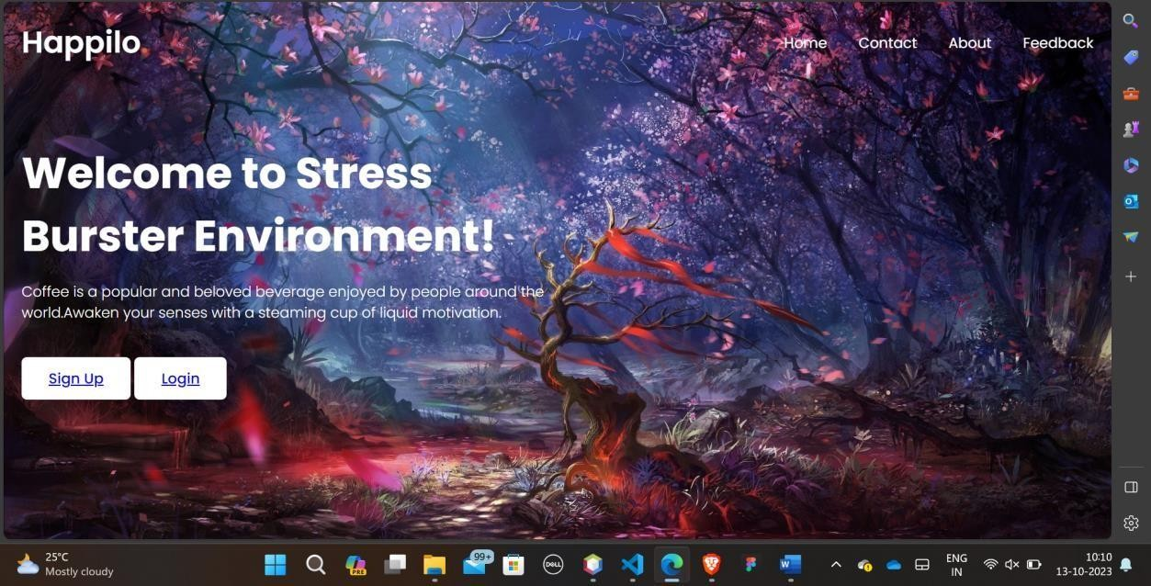

# LOGIN PAGE :

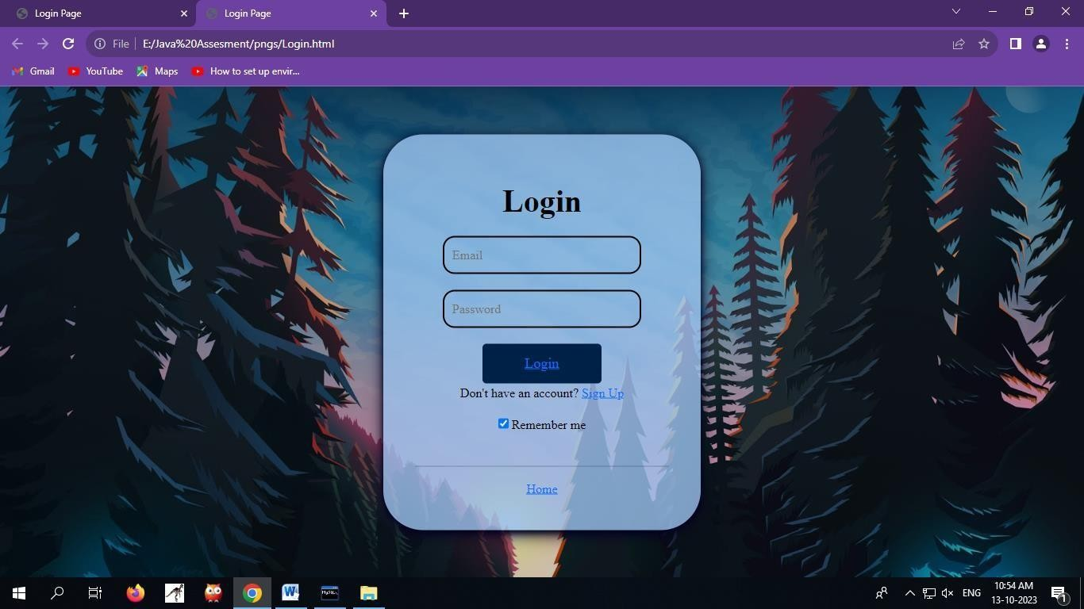

**SIGN UP PAGE :**

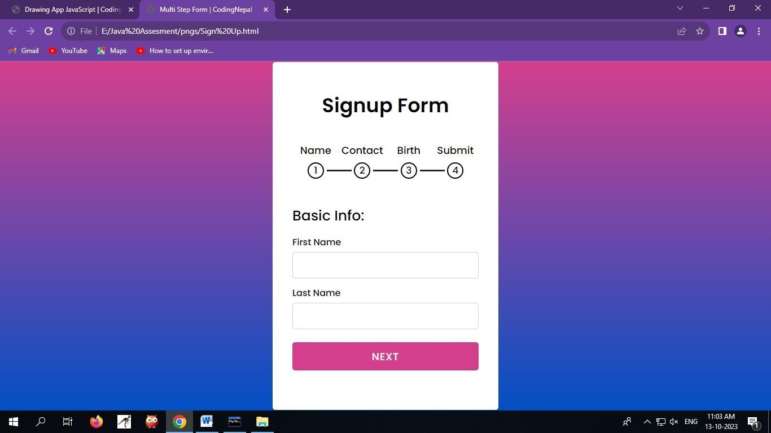

# HOME PAGE :

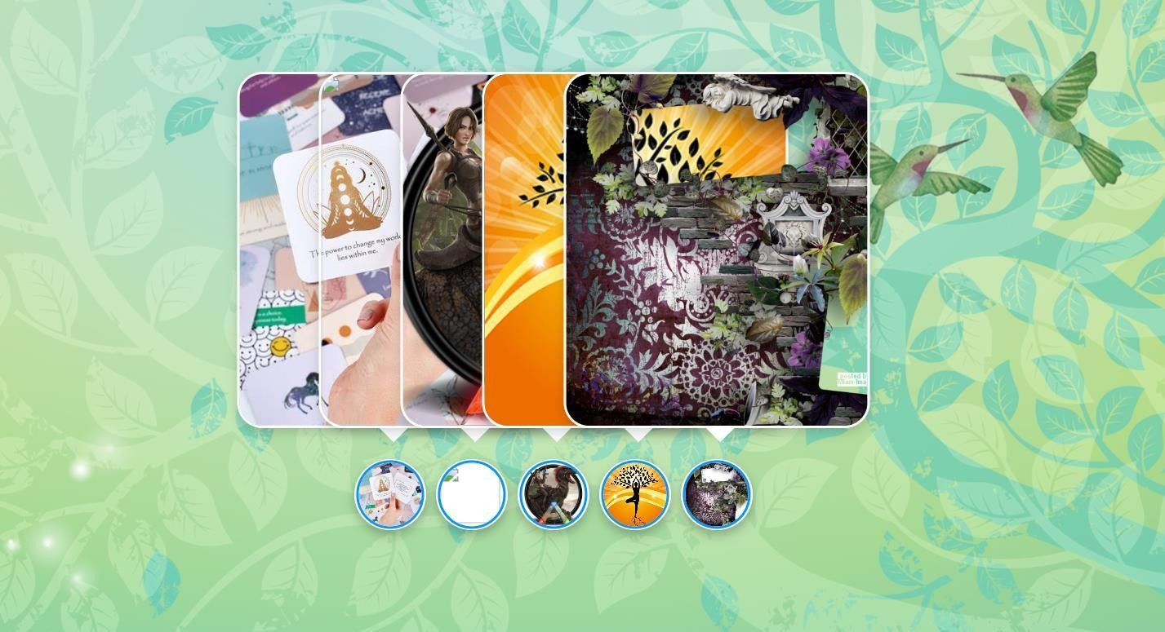

**MUSIC :**

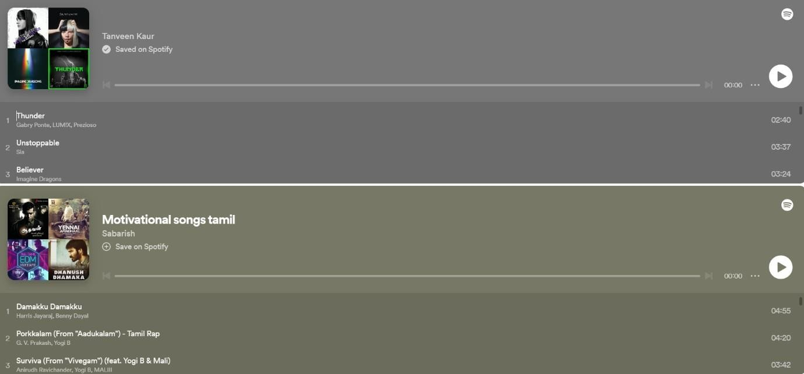

# AFFIRMATION CARD :



**CHESS :**

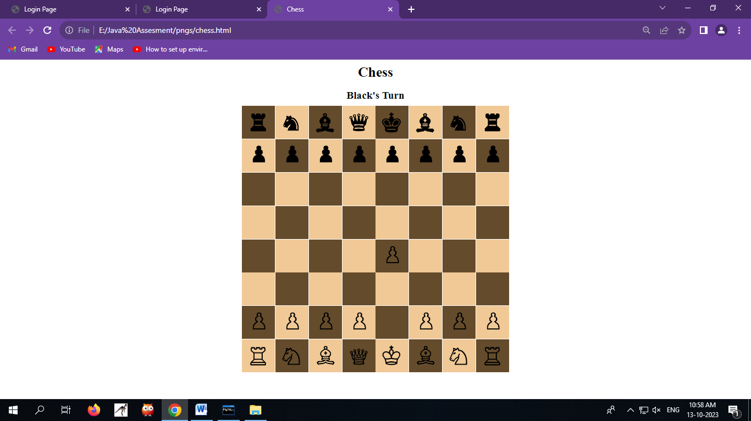

# SNAKES AND LADDER :

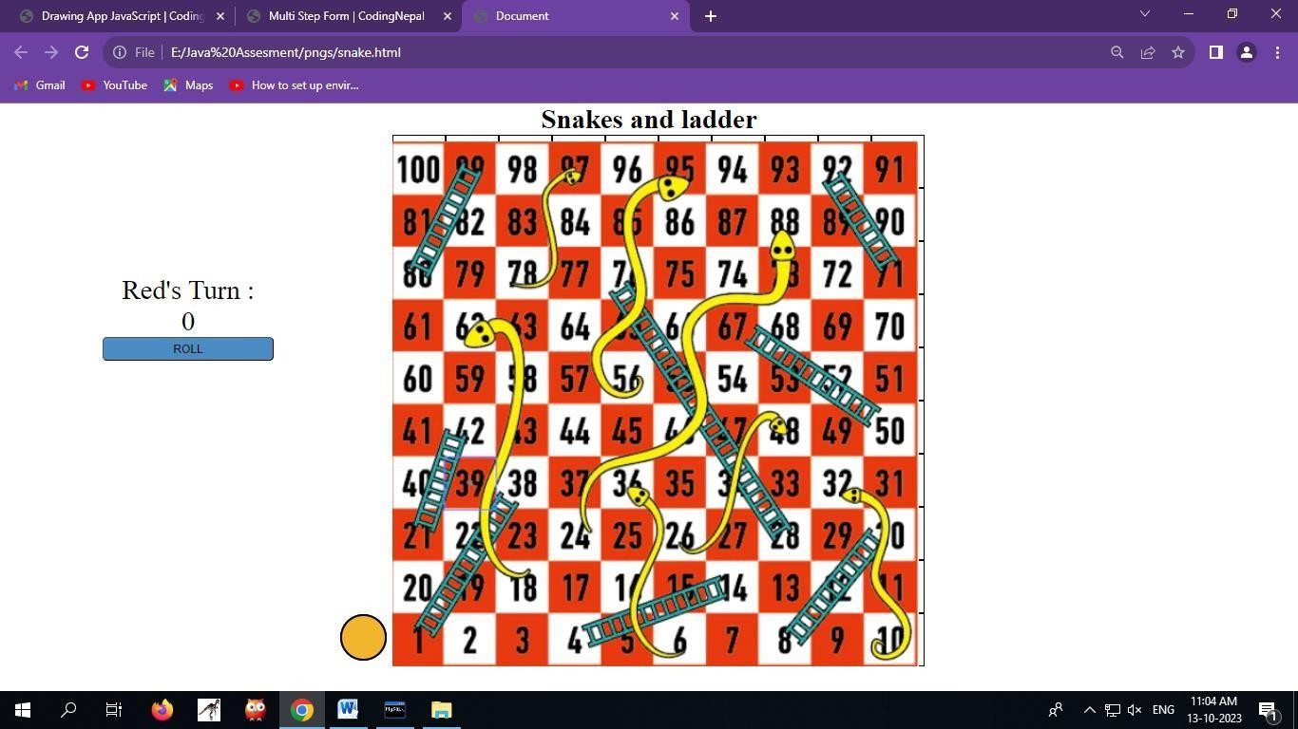

**SCRAPPY :**

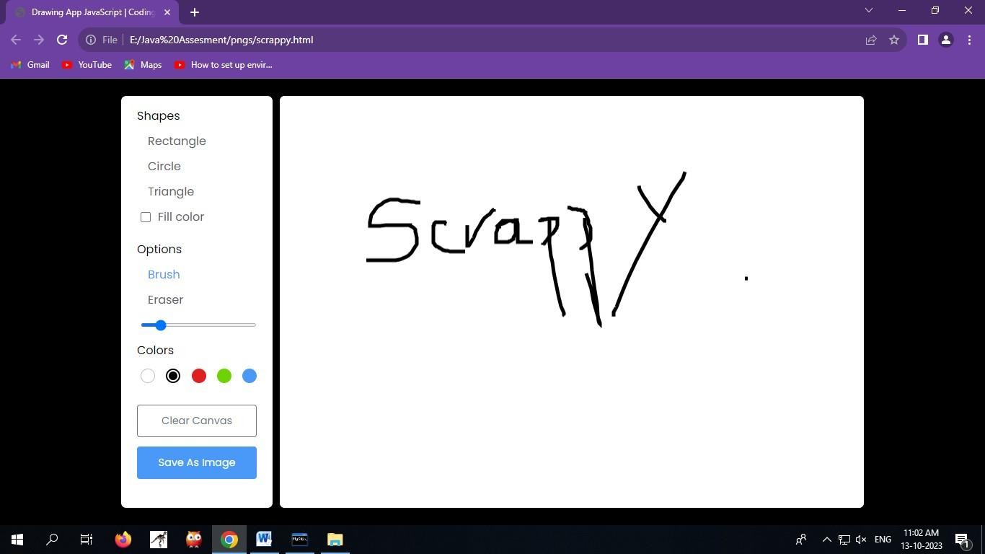

# SPELLING BEE :

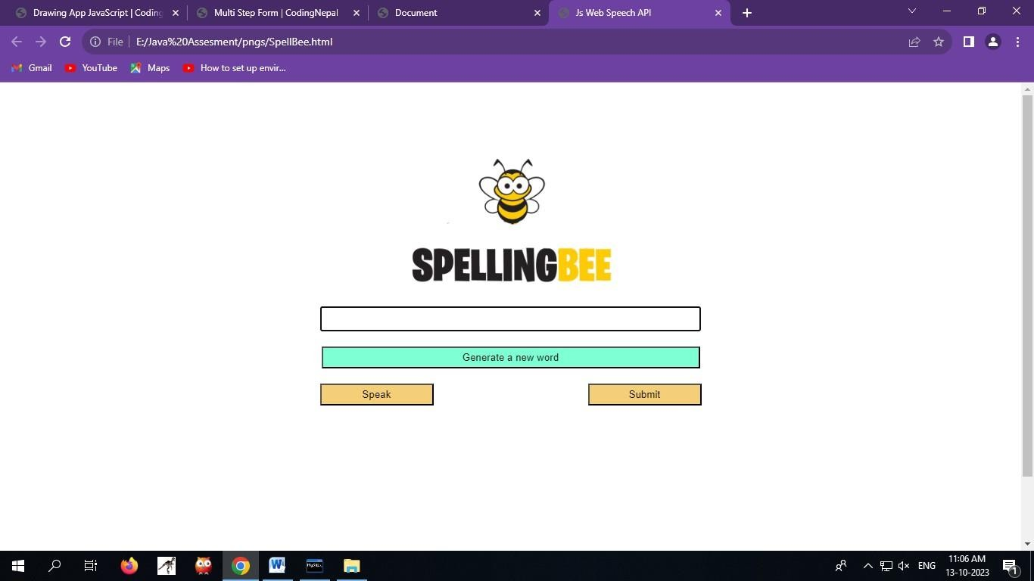

**TIC-TAC-TOE :**

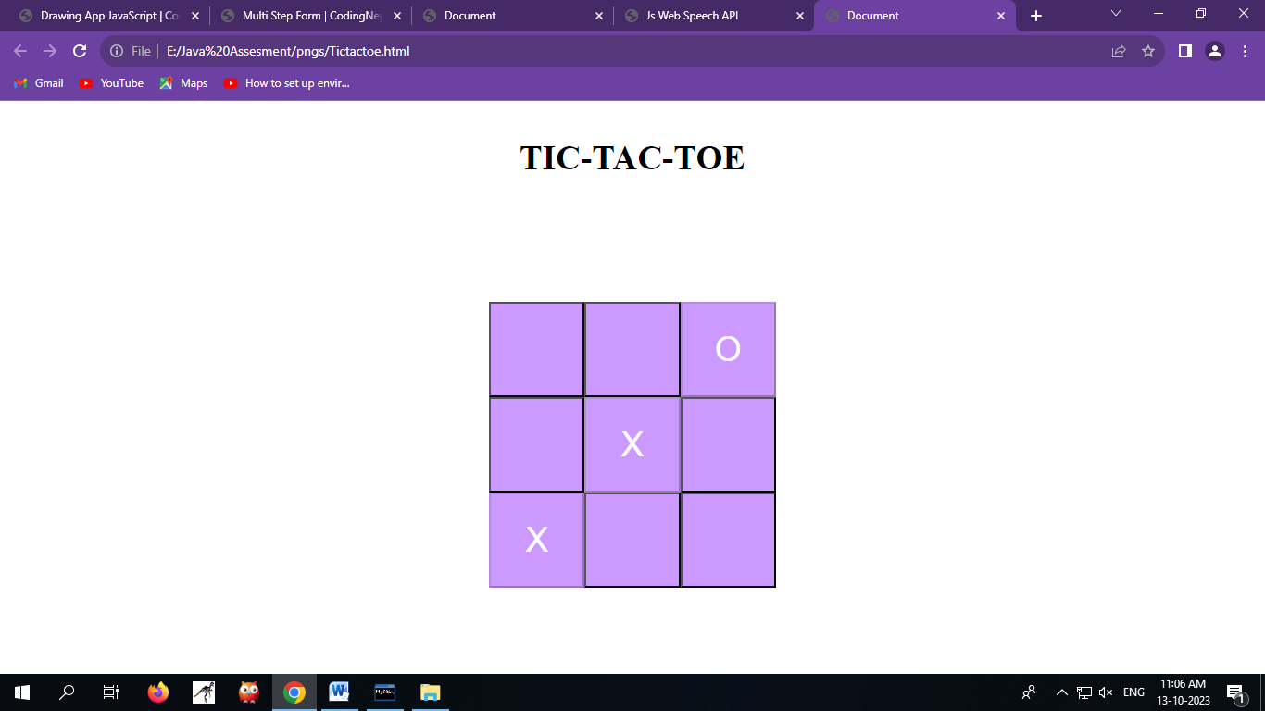

# YOGA PAGE :



**CONTACT PAGE:**

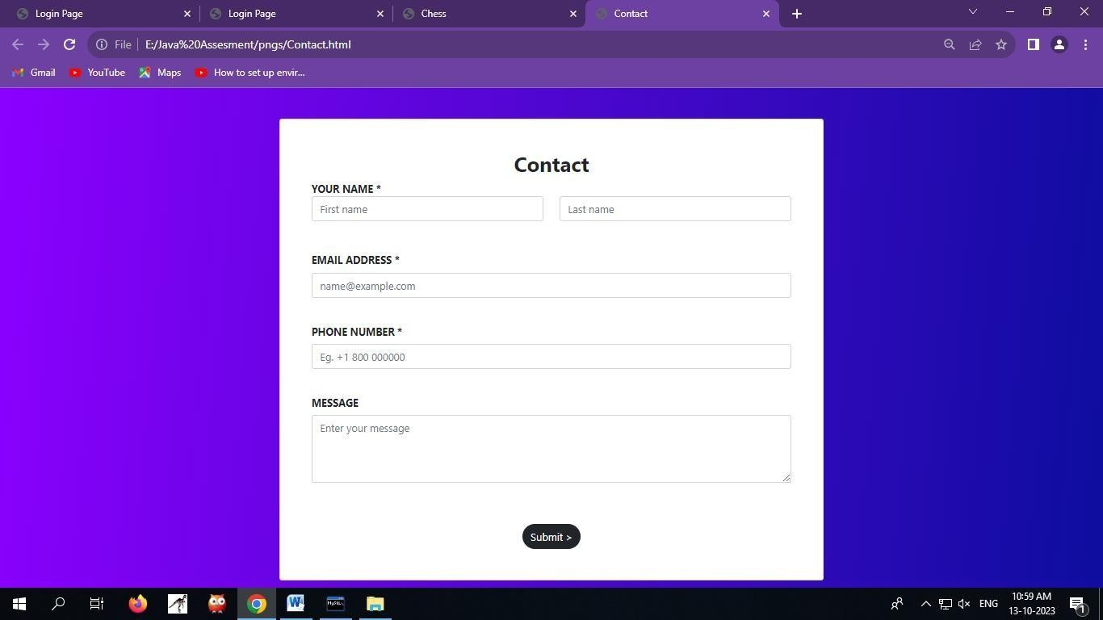

# FEEDBACK FORM :

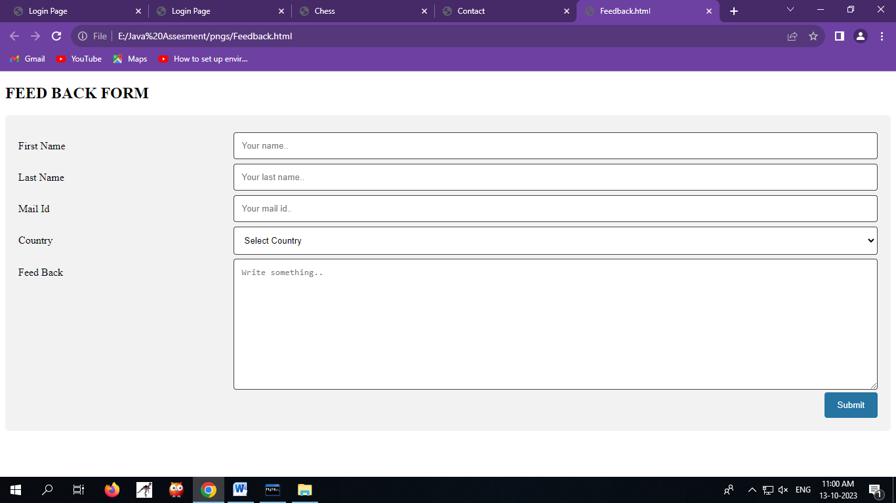

**REFERENCES:**

1. Fleming, T. M., et al. (2017)."Serious games for the treatment or prevention of depression: A systematic review." Health informatics journal.
2. Colder Carras, M., et al. (2018). "Mental health games: An overview." JMIR Serious Games.
3. González-Polledo, E., et al. (2017). "Digital mental health and the question of scalability." Health sociology review.
4. Merry, S. N., et al. (2016). "The effectiveness of SPARX, a computerized self- help intervention for adolescents seeking help for depression: Randomized controlled non-inferiority trial." Journal of Medical Internet Research.
5. King, D., et al. (2017). "Digital games for mental health: A systematic review." Games for Health Journal.
6. Lamont, A., et al. (2019). "Digital interventions to reduce stress in healthcare workers: A systematic review of interventions." Health informatics journal.
7. Kron, A., et al. (2019). "Gaming well: Links between videogames and flourishing mental health." Frontiers in Psychology.
8. Deterding, S., et al. (2015)."From game design elements to gamefulness: defining 'gamification'." In Proceedings of the 15th International Academic MindTrek Conference: Envisioning Future Media Environments.